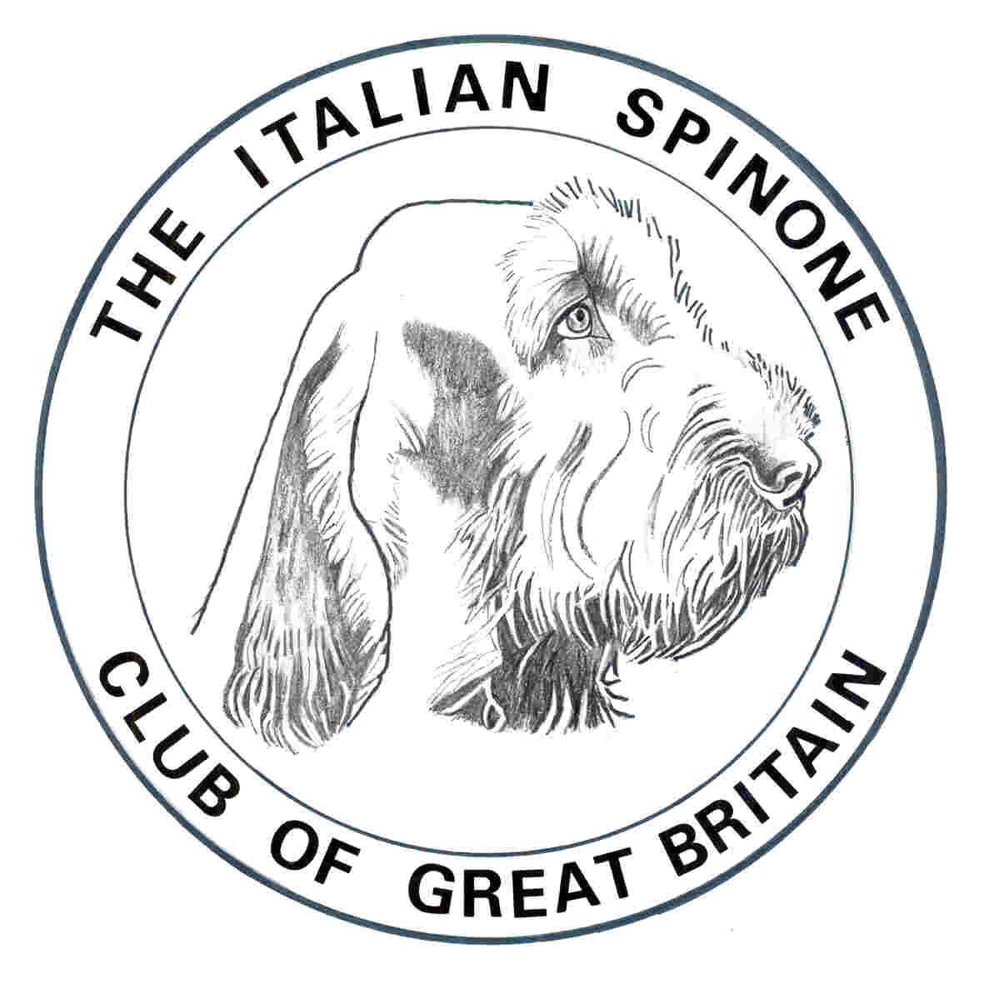
The Italian Spinone Club of Great Britain

Hon Field Trial Secretary
Alix Johnson
1 Ducks Cottages, Nether Wallop, Stockbridge
Hants SO20 8HE
01264 781913
3girlsandtrev@lineone.net

Grouse Pointing Test Entry Form 2018
Wemmergill Moor
There will be runs for 18 Junior HPRs.
Adult HPRs may apply and, in the absence of a full card of Juniors, a draw will be made. Adult Spinoni will be given priority.

Would competitors please ensure they bring credit to the HPR world, on this prestigious moor, by acquainting themselves with the Spring Pointing Test Guidelines and entering dogs that have the necessary skills, stamina and ability.

Name of Dog: …………………………………………………………………………………………

Breed:………………………………………………………….. Sex:…………………………….

Sire……………………………….………………… Dam……………….…………………………….

Date of Birth:……………………...…. Age Group: JUNIOR / ADULT please delete as applicable

Name of Owner:………………………………………………………………………………………..

Name of Handler:………………………………………………………………………………………

Address:…………………………………………………………………………………………………

…………………………………………………………………………………………………………...

Mobile Telephone Number…………….…………………………………………………..…………

Email address:………………………………………………………………………………………….

